PRACTICAL : 4

* **Aim :**

[A] Write a C program that will print parent process id and child process id. Mention error checking if the child process is not created.

* **Code :**

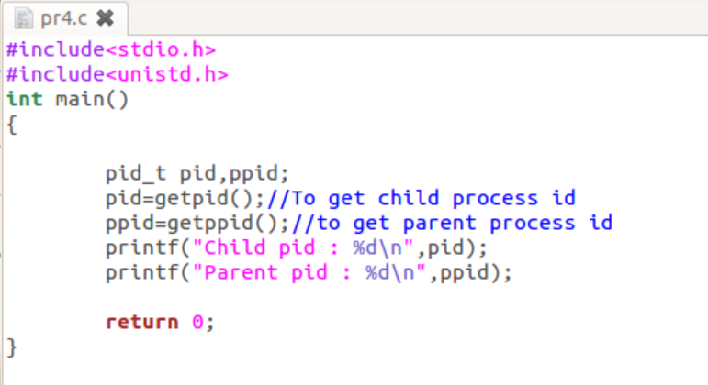

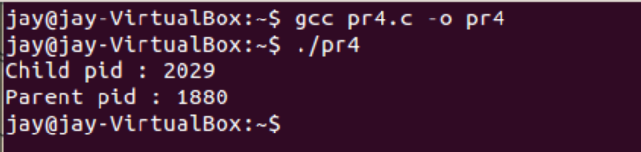

* **TASK (With Assignment):**

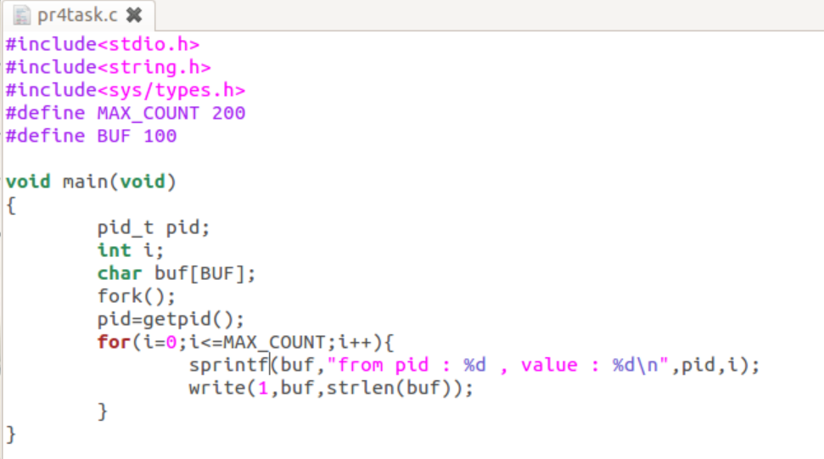

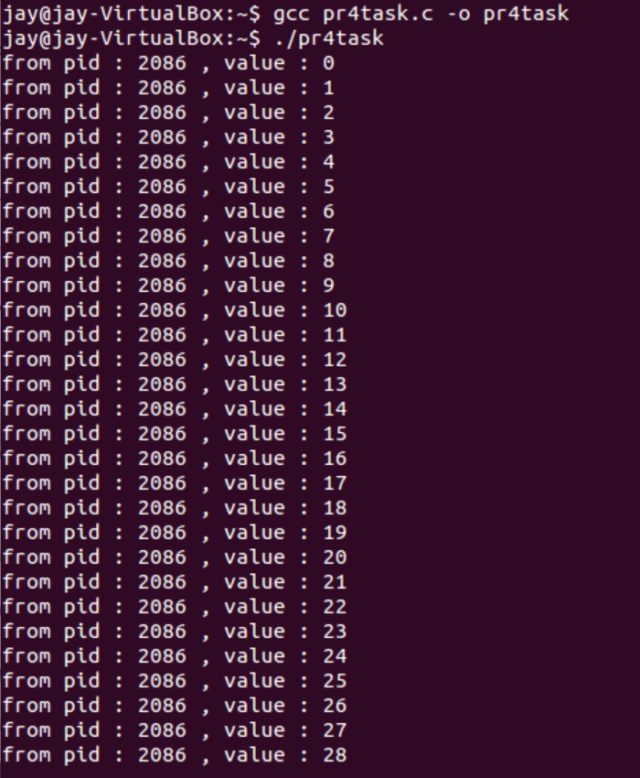

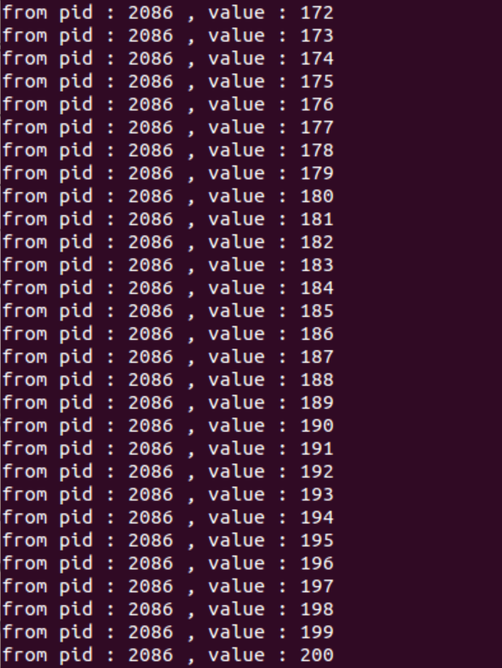

PRACTICAL : 5

* **Aim :**

[B] In continuation of part (a), write a C program where the parent process waits for the child process to terminate.

* **Code (With assignment code):**

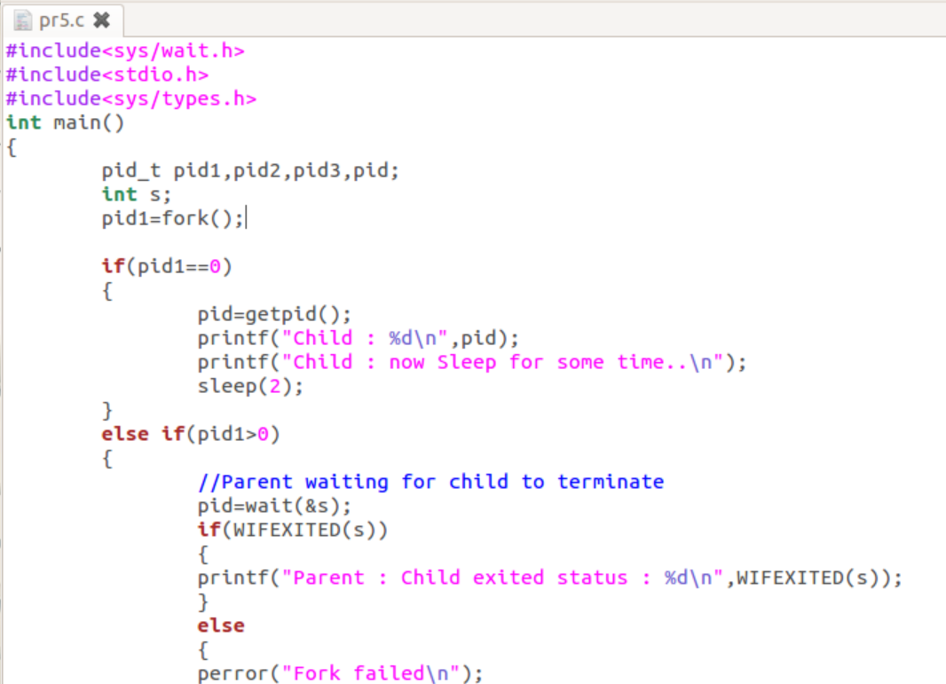

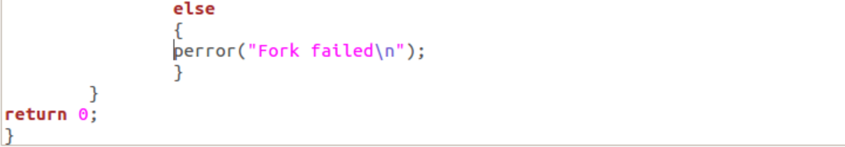

* **Output :**

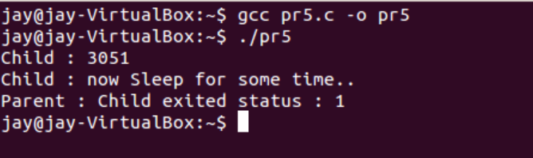

PRACTICAL : 6

* **Aim :**

[C] Write a C program using execvp() system call which will count the characters from file ‘wc’, using program ‘p.c’.

* **Code :**

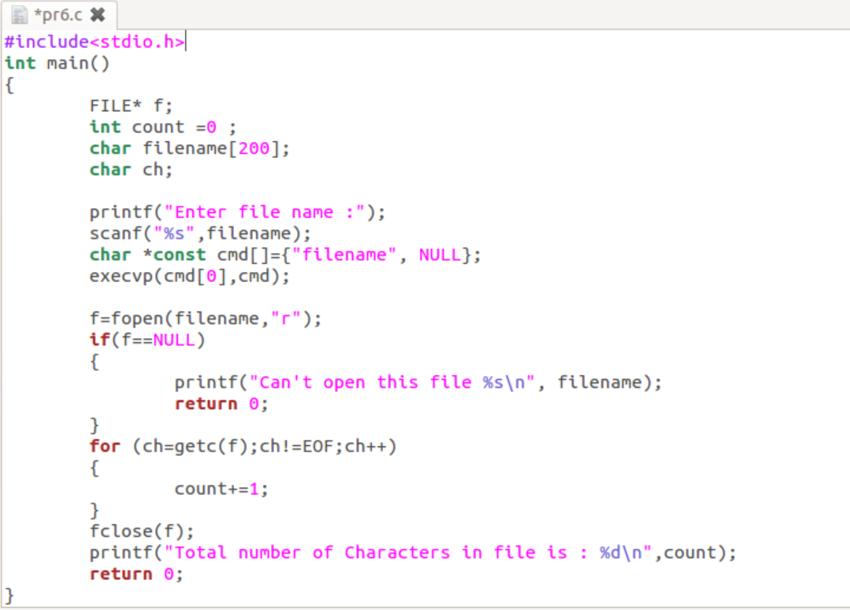

* **Output :**

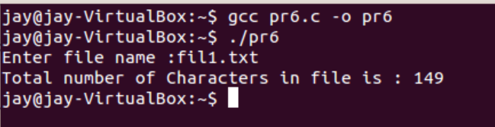

* **TASK :**

